**If you want to run Windows 7 on your PC, here's what it takes:**

* 1 gigahertz (GHz) or faster 32-bit (x86) or 64-bit (x64) processor*
* 1 gigabyte (GB) RAM (32-bit) or 2 GB RAM (64-bit)
* 16 GB available hard disk space (32-bit) or 20 GB (64-bit)
* DirectX 9 graphics device with WDDM 1.0 or higher driver

This step-by-step guide demonstrates how to install Windows 7 Ultimate. The guide is similar for other versions of Windows 7 such as Home Premium.

The best way to install Windows 7 is to do a clean install. It is not difficult to perform a clean installation. Before you start the installation process I recommend that you check Requirement list given above to ensure that your hardware is supported by Windows 7.

Windows 7 DVD is bootable. In order to boot from the DVD you need to set the boot sequence. Look for the boot sequence under your BIOS setup and make sure that the first boot device is set to CD-ROM/DVD-ROM.

**Step 1** - Place Windows 7 DVD in your DVD-ROMs drive and start your PC. Windows 7 will start to boot up and you will get the following progress bar.

[](https://www.buildeasypc.com/pics/windows_7/windows7_1.jpg)

**Step 2** - The next screen allows you to setup your language, time and currency format, keyboard or input method. Choose your required settings and click next to continue.

[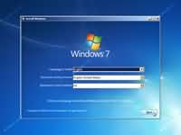](https://www.buildeasypc.com/pics/windows_7/windows7_2.jpg)

**Step 3** - The next screen allows you to install or repair Windows 7. Since we are doing a clean install we will click on "install now".

[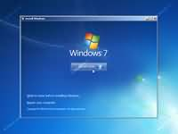](https://www.buildeasypc.com/pics/windows_7/windows7_3.jpg)

**Step 4**- Read the license terms and tick I accept license terms. Then click next to continue.

[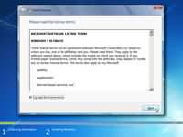](https://www.buildeasypc.com/pics/windows_7/windows7_4.jpg)

**Step 5** - You will now be presented with two options. Upgrade or Custom (Advanced). Since we are doing a clean install we will select Custom (Advanced).

[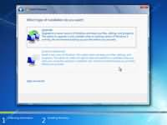](https://www.buildeasypc.com/pics/windows_7/windows7_5.jpg)

**Step 6** - Choose where you would like to install Windows 7. If you have one hard drive you will get a similar option to the image below. You can click next to continue. If you have more than one drive or partition then you need to select the appropriate drive and click next. If you need to format or partition a drive then click Drive options (advance) before clicking next.

[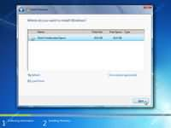](https://www.buildeasypc.com/pics/windows_7/windows7_6.jpg)